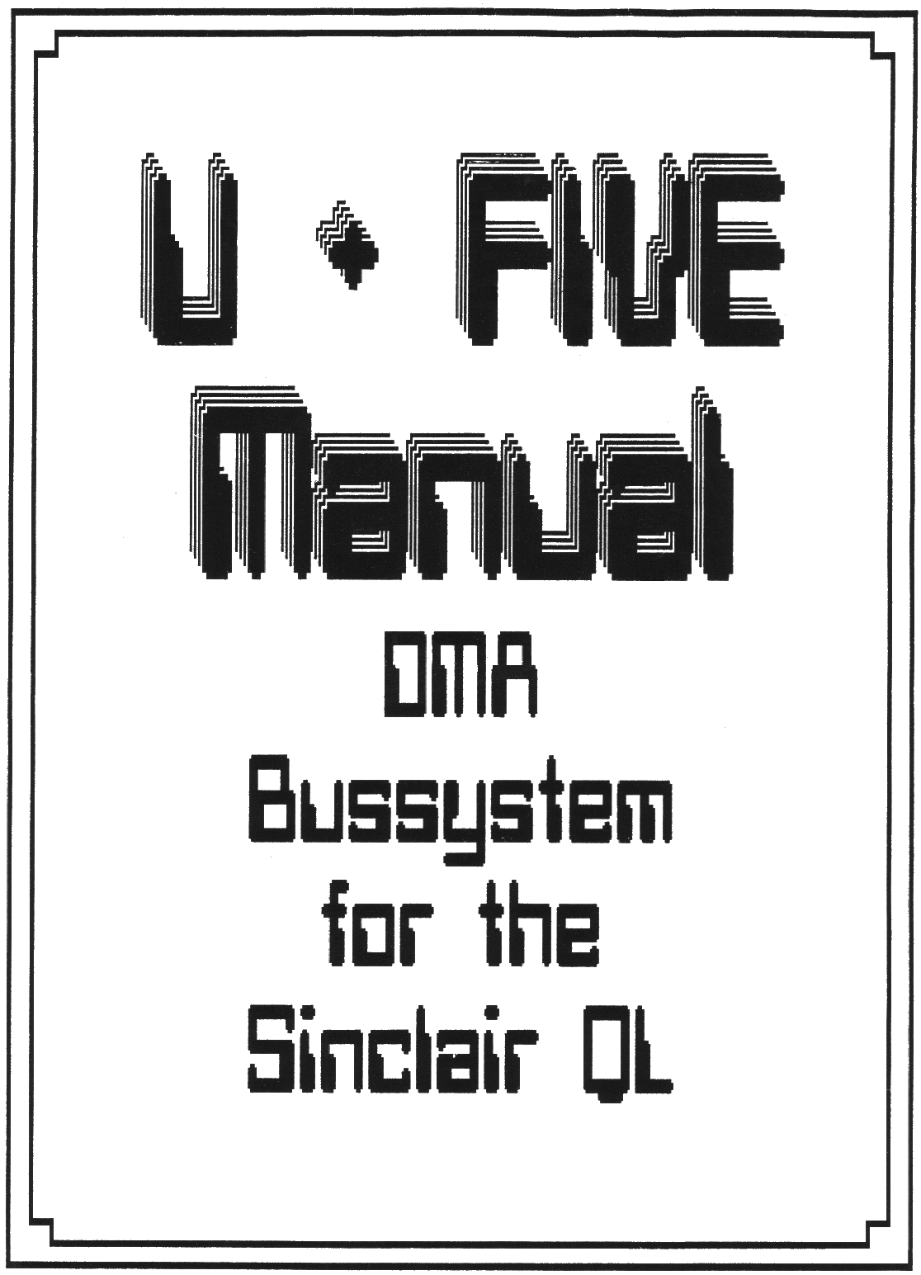

FEATURES
All relevant signals buffered
Epromsocket for easy upgrading Qdos.
Jumper to select extension card adress
DMA capability

Power supply connections easy to alter for using a lot of different types of power supplies to supply QL and / or the bus buffer.

Introduction
The bus buffer was developed, to build in the QL in an IBM or compatible Case or in a 19” Eurocase. Also it was boring and harmful( for QL and mind), while using the eprommer, no floppy is running or some Qboard’s don’t work with some QL’s (just your’s).
The bus-buffer is able to drive DMA cards like a harddisk. You have 6 slots (1 for the cable) and a lot of possibilities to connect different types of power supplies, which are required for more than 2 extensioncards. The buffer and the bus are linked with a 64 c. 13” long flat ribbon cable. The bus buffer drives all extensioncards, but not the Trumpcard and a built in ram extension. The Trumpcard will not supported, ‘cause it uses all expansion place for ram. For internal ram extensions, you can order a special PAL.

Connections
Switch off your QL. Pull out the extensioncard. Now insert the buffer PCB. If you have fitted an uprade Qdos eprom, pull out the original QL ROM’s. Now set the jumper for the extension adress and the power supply. Default is:
POWER SUPPLY 9V, +12V, -12V from QL
EXP. ADRESS 0,4,8,12,1
Now insert the flat ribbon cable into the plug from the buffer. The other side insert in the plug No.5.
CAUTION !!!!!
The coloured conductor must be on the same side at the buffer and the bus. If the coloured conductor is at the buffer voltage regulator, the coloured conductor must near the l6pin plug on the bus.
Now switch on your QL. If it starts, ssiitch off and insert your extension cards. Switch on again. You should see all copyright messages on the startup screen.
CAUTION !!!!
JM and earlier Qdos versions only recognize one extension. Burn a 27512 Eprom with a JS or MG version and plug it into the free 28 pin socket on the buffer card. Don’t forget to pull out the internal Qdos ROMs.
Remember that you need a stronger or a second power supply for more than one or two extensions.

EXTENSION ADRESS
To use more than one card together, The extension card must have different adresses. Normally the adress is C0000hex + 0 for the first card. With the lines sp0 to sp3 you specify the adress in steps of 16kb in binary code. (sp0=LSB)

adress sp3 sp2 sp1 sp0 C0000hex +
0 0 0 0 0 0
1 0 0 0 1 4000
2 0 0 1 0 8000
3 0 0 1 1 c000
4 0 1 0 0 10000
5 0 1 0 1 14000
and so on until 3c000

The first slot is set to 0, the default of the other is set to 4, 8, 12 and 15.

CAUTION
The SuperQboard needs 2 or more adresses. To find out how much place it needs, look at the eprom. 27128 = 1 / 27256 = 2 / 27512 = 4 adresses.
for example: On your Qboard is an 27256, so it needs 2 actresses. Insert the Qboard in slot 0. Now the Qboard software takes the space from slot 1 too, so you must set slot 1 to 2, 2 to 3 and so on. But you can either put the Qboard in slot 4, or set slot one to adress 5. ( The default is 0,4,8,12,15 so it is not necessary to change the adress)
Bare ramextensions need no adress.

POWER SUPPLY
To use all slots, you need a better power supply with a current around 4 Ampere.
To connect another power supply, look at the following list to find out the right jumper setting.
ji 9v from QL to bus (closed)
j2 -12v from QL to bus (closed)
j3 +12v from QL to bus (closed)
j4 9V from connector to QL
j5, j6 as j4, but -12v and +12V
The other connectors are for connecting unregular powersupplies like a switchmode from IBM. There is a place for a 9V regulator for those people who want to supply the QL and the bus with 5 Volt (all 5 Volt regulators pulled out), but the microdrives are needing still 9 Volt.
In picture 1 to 4 are some application examples.

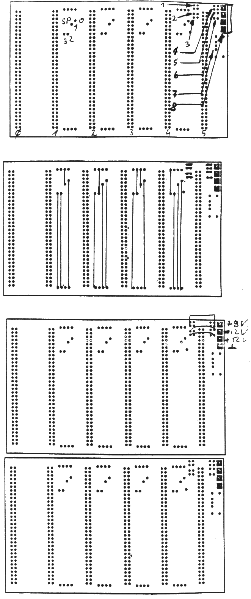
Picture 1
1=J1 double jumper to connect 9V from QL to bus
2=J2 to connect -12V from QL to bus
3=J3 like J2 but +12V 4=J4 double jumper to connect 9 or 5V from extra power supply to QL and bus (j1 closed)
5,6 = j5,j6 like j4, but -12v and +12v.
7=place for 9v regulator, to serve microdr. by using 5v for QL and bus
8 plug for extra power supply
picture 2
normal jumper settings.
The resistors are to divide the 9v to 4,5v for logic 1 at the SP lines. Using the ex.cards with 5v, you can use a normal conductor to 5V.
picture 3
This picture shows the connections for extra power supply: required are 9 or 5v 4A, +12v, -12V. QL wil not be supplied. Using 5V, don’t forget to pull out the regulators and connect pin 1 and 3 on the PCB, but beware to use these cards in a normal QL. They will be damaged.

CHANGING THE QL POWER SUPPLY TO 5V
1) Remove the keyboard of the QL and pull out the plugs of the keyboard membrane and the LED’s.
2) Remove the heatsink and the 5 Volt regulator.
Bridge the left and the right pin of the 5V regulator socket. Also remove IC36, IC37 and, if not required, the microdrives.
If you want to keep the microdrives cut the 9V track on the circuit board and connect the 9V pin of the microdrives with the 9V connector of the buffer PCB.
At last you should take a thicker lead and connect the main expansion port (pin 32,a,b) with the bridged 5V regulator socket in order to improve the current flow between the bus buffer and the extension cards.
That’s all.
The original QL power supply is not needed any longer as the power supply comes now from the bus buffer. If you want to build in the QL in an IBM case etc. you should solder the 5V voltage lead on the bus buffer and on the QL. Suitable points for this are the VG connector (slotplug) and the bridged 5V regulator socket.
It should be clear that the voltage regulator on every extansioncard has to be bridged in the same way as described above!!!
I point out that every effort has been made to ensure that the information given in this manual is as accurate as possible, however, I will not accept any responsibility for losses or damage caused directly or indirectly from its use.
CAUTION
You can’t use the extansioncards without the voltage regulator on a standard QL with 9V power supply.
If the are any questions, please phone or write to:
Ulrich Rosowski
Neuwerker Straße 16
Tel. : 0211/ 4541728
4000 Düsseldorf

