QSOUND / QPRINT

This upgrade adds to the good characteristics of the QL a 'real' sound generation facility and a parallel printer interface .

Fitting the board
Ensure that the QL is disconnected from the mains. If you do not you may damage the QL, the QSOUND/QPRINT board or both. Remove the rectangular plastic cover on the left hand side of your QL which covers the expansion bus slot. This may require some effort.
Now push the QSOUND/QPRINT board firmly in the expansion slot. This may take also a little effort. You should be able to feel when the board is firmly in place.

To test your new upgrade connect the QL to the mains. After the usual memory test screen, the TV / Monitor selection screen will appear with an additional copyright message from the QSOUND/QPRINT board. If you have connected an amplifier you should hear a short sound like a bell: QSOUND/QPRINT tells you that It is OK! After pressing F1 (or F2) you can use the full power of your QSOUND/QPRINT expansion.
To connect an amplifier to the QSOUND/QPRINT card, there is a 3.5 mm cinch socket on the left hand side of the card. You will also find a centronics compatible printer inter face there.

Obligatory notice
QL, DOS, Microdrive and SuperBASIC are trade marks of Sinclair Research Ltd.
ABACUS, ARCHIVE, EASEL and QUILL are trade marks of Psion Ltd.

PARALLEL INTERFACE

Use
After powering up and initialisation you can use a new QL device named PAR.
You can connect a centronics compatible printer to the parallel interface and use it via the device name PAR. A procedure to list the actual SuperBASIC program to a printer connected to the PAR port could look like this:

30000 DEFine PROCedure llist
30001 OPEN #3,PAR : LIST #3 CLOSE #3
30002 END DEFine

Buffers
You can use a part of the QL’s RAM as a buffer for efficient print spooling. Its size in blocks of 512 bytes must be specified in the OPEN command as in the following examples:

OPEN #3, PAR_1 512 byte buffer
OPEN #3, PAR_32 16 kbyte buffer

The maximum buffer size is 63 kbytes .

Options
Two options are accepted as part of the device name.

PARC_<bfsize> The ‘C’ flag is used if the <LF> character (chr$(10)) should be converted to a <CR> character (CHR$(13))

PARF_<bfsize> The ‘F’ flag is used if a <FF> character should be sent when the channel is closed.

PARCF_<bfsize> Combination of the two flags is allowed.

SER emulation
Using the new PAR_USE command you can get the benefits of your new parallel interface without changing existing programs . This command accepts a three character device name (with or without string quotes) as a parameter .

PAR_USE SER will emulate the SER ports of the QL. All output sent to the serial port will be send to the new PAR device.

Psion software
If you want to use the PAR interface with ABACUS, ARCHIVE EASEL and QUILL you may include the PAR USE command in the corresponding boot program.
Alternatively, you can also change the printer driver with the INSTALL_BAS program supplied with the Psion software package: Load and run the program and choose the Microdrive as required. Choose the PAR port option by pressing the space bar. Get the list of printer parameters by pressing F2. Change the PORT by pressing either the left or right cursor key and then type 'PAR' as the valid device name
Don’t use a buffer unless you have a memory expansion as the Psion programs use the entire RAM of an unexpanded QL. Don't add the flags ‘C’ or ‘F’. You can obtain these options specifying the END OF LINE code as CR and by including FF in the POSTAMBLE CODE, respectively.

ADDITIONAL SUPERBASIC COMMANDS

The QSOUND/QPRINT firmware consists of 30 new SuperBASIC commands which allow you to utilize the PAR interface and the full capability of the sound chip. A few useful procedures/ functions are also included.
The commands are described below. Parameters enclosed in < > are optional. The default window is #1.

BELL procedure
Causes the sound chip to emit a short bell like sound

CONTROL procedure
Creates a job which opens a window in the upper right-hand corner of the screen shows the number of the job that is currently ready to receive input (i.e. whose cursor is flashing)

CUR_FLASH f procedure
Changes the flashing rate of the cursor
f = 0 normal
f = 1 medium
f = 2 high

CURDIS <#n> procedure
disables the cursor in window #n

CURSEN <#n> procedure
enables the cursor in window #n
The INKEY$ command doesn’t show a cursor. The following function also returns the character corresponding to the key pressed but shows a flashing cursor for the number of frames specified in wait

DEFine FUNction getkey$(chn, wait)
CURSEN #chn
r$=INKEY$(#chn, wait)
CURDIS #chn
RETurn r$
END DEFine

m = D_MODE function
returns the current display mode
m = 4 high resolution (4 colours)
m = 8 low resolution (8 colours)

t = D_TYPE function
returns the current display type (which determines the default windows)
t = 0 monitor
t = 1 TV

DOWN (#n) procedure
moves the cursor in window #n one row down

EXPLODE procedure
causes the sound chip to emit an explosion like noise

HOLD procedure
stops all interrupt sound lists

HOLD n procedure
stops the interrupt sound list n (1 .. 3)

LEFT (#n) procedure
moves the cursor in window #n one column to the left

LIST_AY r0..r13 procedure
sends the value of r0 .. r13 to the registers 0 .. 13 of the sound chip

nno = NET_NR function
returns the network station number of your machine which was assigned by the SuperBASIC command NET

NEW_FONT <#n>, add procedure
assigns the new character font at address add to window #n

OLD_FONT #n procedure
Assigns the standard QL font to window #n

PAR_STOP procedure
clears the PAR device buffer and stops printing via the PAR port

PAR_USE ddd procedure
renames the PAR device to the new three character name ddd. Useful for SER emulation.
PAR_USE SER emulates the serial port 1.

v = PEEK_AY (r) function
Returns the content of register r of the sound chip

PLAY n, sound$ procedure
puts the string sound$ into the interrupt list of the sound channel n (1 .. 3) .
sound$ may contain various characters (case is not distinctive) to denote

notes: C D E F G A H
(H corresponds to B, HB to Bflat)
Sharps: #
Flats: b
Rests: p (one length unit)
Change octave: o0 o1 .. o7
(default o2)
Change volume: v0 v1 .. v15
V16 switches to wrap control
Duration of note in 1/50 sec: 10 .. 1255
(default: 15)
Change noise frequence: n0 n1 .. 31
(default n0)
Determine wrap curve: w0 w1 .. w15
(default w0)
Change length of wrap: x0 x1 .. x32767
(default is x0)
Synchronisation stop: 5
causes a sound channel to wait
activate a waiting channel: r1 r2 r3

Sound example (try it):
PLAY 1, 'pr15o4sCDEFGAHo5CDEFGAHp'
PLAY 2, 'pv15o2r1CDEFGAHo3CDEFGAHp'

POKE_AY r,v procedure
Sets one of the registers (0 .. 13) of the sound processor to value v (0 .. 255)

vno$ = QDOS$ function
returns the version number of your QDOS operating system

RELEASE procedure
Causes all interrupt sound lists to be played

RELEASE n procedure
Causes the sound list n (1 .. 3) to be played

RIGHT <#n> procedure
Moves the cursor in window #n one column to the right

SHOOT procedure
Causes the sound chip to emit a noise like a shot

SOUND procedure
Clears all sounds played by the sound chip. All tunes in the sound interrupt lists created with the PLAY command are cleared.

SOUND n procedure
Clears the sound channel n (1 .. 3)and the corresponding interrupt list

SOUND n,f,v procedure
Sets the sound output to sound channel n to the frequency f (400 … 5000 Hz) and the volume v (0 .. 15)

UP <#n> procedure
Moves the cursor in window #n one row up

MACHINE CODE PROGRAMMING WITH THE AY-3-8910 SOUND PROCESSOR

The QSOUND/QPRINT card could theoretically occupy any of the 16 expansion slots recognised by QDOS. To find the actual base address, read the system variable SV.AYBAS. The address to jump to is in the system variable SV.AYJMP.
The sound processor control routines are called with a code in the register D0 of the MC68000 (like the QDOS trap routines).
A call to the routine AY.RDREG (which reads a register of the AY-3-8910) should look like this:

MOVEQ #AY.RDREG,D0 code for AY-routine
MOVEQ #0,D2 read register $00
MOVE.L SV.AYJMP,A0 get address to jump to
JSR (A0) do it

A QDOS error code will be returned in D0.

ROUTINE AND ADDRESS SUMMARY
ADDRESS DEFINITIONS

Name Address Description

SV.AYBAS $28160 long Base address of the firmware
SV.AYJMP $28164 long Start address for machine code
Routines

ROUTINES FOR SOUND CONTROL
D0 Name Description

$00 AY.RESET clears sound, stops noise
$01 AY.WRREG writes one AY-3-8910 register
$02 AY.RDREG reads one AY-3-8910 register
$03 AY.WRALL writes all (0 .. 13) registers
$04 AY.RDALL reads all (0 .. 15) registers
$05 AY.PLAY plays a tune
$06 AY.TSTPL status query
$07 AY.HOLD causes a sound channel to wait
$08 AY.RELSE releases a waiting channel
$09 AY.NOISE emits a predefined noise
$0A AY.SOUND emits a user-defined sound

HARDWARE KEY
Name Address Description

AY.PORTA $8000 PIA-Dataport A
AY.CTRLA $8001 Control port A
AY.PORTB $8002 PIA-Dataport B
AY.CTRLB $8003 Control port B

D0 = $00 AY.RESET

Clears the sound.

Call parameters Return parameters

D1 D1 undefined
D2 D2 undefined
D3 D3 preserved

A0 A0 preserved
A1 A1 undefined
A5 undefined

ERROR RETURNS
None

NOTES
Also clears all sound interrupt lists.
D0 = $01 AY.WRREG

Writes a value to AY-3-8910 register.

Call parameters Return parameters

D1.B value D1 preserved
D2.B register D2 preserved
D3 D3 preserved

A0 A0 preserved
A1 A1 preserved
A5 undefined

ERROR RETURNS
ERR.OR Invalid register number (>13)

NOTES
Please note, that only registers 0 .. 13 are used. The other ports are used for the PAR interface. Bit 6 and 7 of register 7 remain unchanged. They are also used for port managing.

D0 = $02 AY.RDREG

Reads a AY-3-8910 register.

Call parameters Return parameters

D1 D1 value read
D2.B register D2 preserved
D3 D3 preserved

A0 A0 preserved
A1 A1 preserved
A5 undefined

ERROR RETURNS
ERR.OR Invalid register number (>15)

D0 = $03 AY.WRALL

Writes all registers (0 .. 13) of the AY-3-8910.

Call parameters Return parameters

D1 D1 undefined
D2 D2 undefined
D3 D3 preserved

A0 A0 preserved
A1.L pointer to datablock A1 undefined
A5 undefined

ERROR RETURNS
None

NOTES
The datablock must contain 14 bytes with the values for the registers in ascending order ($00 = r0 .. $0C = r13).

D0 = $04 AY.RDALL

Reads all registers (0 .. 15) of the AY-3-8910.

Call parameters Return parameters

D1 D1 undefined
D2 D2 undefined
D3 D3 preserved

A0 A0 preserved
A1.L pointer to buffer A1 undefined
A5 undefined

ERROR RETURNS
None

NOTES
The 16 bytes buffer contains the values of the registers in ascending order ($00 = r0 .. $10 = r15).

D0 = $05 AY.PLAY

Puts a string to the interrupt sound list.

Call parameters Return parameters

D1.B AY-channel D1 undefined
D2 D2 preserved
D3 D3 preserved

A0.L pointer to the string A0 undefined
A1 A1 preserved
A5 undefined

ERROR RETURNS
ERR.OR AY-channel was not 1, 2 or 3.
ERR.BP String contains undefined sound items.

NOTES
The string must be preceded by a word containing the string length.

D0 = $06 AY.TSTPL

Returns the status of a AY-3-8910 channel buffer.

Call parameters Return parameters

D1.B AY-channel D1 status
D2 D2 preserved
D3 D3 preserved

A0 A0 preserved
A1 A1 preserved
A5 undefined

ERROR RETURNS
ERR.OR AY-channel was not 1, 2 or 3.
ERR.NO Sound list doesn’t exist.

NOTES
Status return in D0: 0 waiting.
1 playing

D0 = $07 AY.HOLD

Suspends playing a sound list.

Call parameters Return parameters

D1.B AY-channel D1 undefined
D2 D2 undefined
D3 D3 undefined

A0 A0 undefined
A1 A1 undefined
A5 undefined

ERROR RETURNS
ERR.OR AY-channel was not 0, 1, 2 or 3.
ERR.NO Sound list doesn’t exist.

NOTES
AY-channel number 0 stops playing on all channels.

D0 = $08 AY.RELSE

Releases a suspended sound list.

Call parameters Return parameters

D1.B AY-channel D1 undefined
D2 D2 undefined
D3 D3 undefined

A0 A0 undefined
A1 A1 undefined
A5 undefined

ERROR RETURNS
ERR.OR AY-channel was not 0, 1, 2 or 3.
ERR.NO Sound list doesn’t exist.

NOTES
AY-channel number 0 causes all channels to continue.

D0 = $09 AY.NOISE

Causes the sound processor to emit predefined noises.

Call parameters Return parameters

D1.B noise D1 undefined
D2 D2 undefined
D3 D3 preserved

A0 A0 preserved
A1 A1 undefined
A5 undefined

ERROR RETURNS
ERR.BP noise > 2

NOTES
Values of noise: 0 explosion
1 gunshot
2 bell

D0 = $0A AY.SOUND

Emits a sound with a specific frequency and volume on the chosen channel.

Call parameters Return parameters

D1.B AY-channel D1 undefined
D2.W frequency D2 undefined
D3.B volume D3 undefined

A0 A0 preserved
A1 A1 preserved
A5 undefined

ERROR RETURNS
ERR.BP AY-channel was not 1, 2 or 3
ERR.OR Frequency was out of range.

NOTES
The valid frequency is 400 .. 5000 Hz.
The valid volume code is 0 .. 15.

REGISTERS OF THE AY-3-8910 SOUND PROCESSOR

The sound processor AY-3-8910 works with a 0.75 MHz time frequency on the QL. It uses 16 read/write registers. The use of the registers is described below.

Reg bit 7 6 5 4 3 2 1 0

$00 chn A tone LSB 7 6 5 4 3 2 1 0
$01 chn A MSB x x x x B A 9 8
$02 chn B tone LSB 7 6 5 4 3 2 1 0
$03 chn B MSB x x x x B A 9 8
$04 chn C tone LSB 7 6 5 4 3 2 1 0
$05 chn C MSB x x x x B A 9 8
$06 noise period x x x x 3 2 1 0
$07 release ioB ioA nC nB nA sC sB sA
$08 chn A amplitude x x x w 3 2 1 0
$09 chn B amplitude x x x w 3 2 1 0
$0A chn C amplitude x x x w 3 2 1 0
$0B wrap period LSB 7 6 5 4 3 2 1 0
$0C wrap period MSB F E D C B A 9 8
$0D wrap curve x x x x w3 w2 w1 w0
$0E I/O port A 7 6 5 4 3 2 1 0
$0F I/O port B 7 6 5 4 3 2 1 0

NOTES
X: bit not used
ioA: If bit is set then port A is input channel else it is output channel
ioB: If bit is set then port B is input channel else it is output channel
nA .. nC: If bit is reset channel is emitting noise.
sA .. sC: If bit is reset channel is emitting sound.
w0 .. w3: Wrap curve (cf. page 22)
w: Bit activates wrap control.

Registers $00 .. $05 define the pitch of the channel. Two registers define a note. The main time is divided by 16. By counting down the 12-bit-counter the output frequency is generated.
Register $06 defines the noise frequency. This works like the pitch control but with 5 bits only.
Register $07 releases the sources. It selects silence, sound, noise or sound and noise for each channel.
Registers $08 .. $0A define the volume. The four LSBits denote the volume in logarithmic steps. The w-bit activates the wrap control.
Registers $0B and $0C define a 16-bit wrap period.
W3 w2 w1 w0 | Wrap curve
0 0 x x  0 1 x x  1 0 0 0  1 0 0 1  1 0 1 0  1 0 1 1  1 1 0 0  1 1 0 1  1 1 1 0  1 1 1 1 | 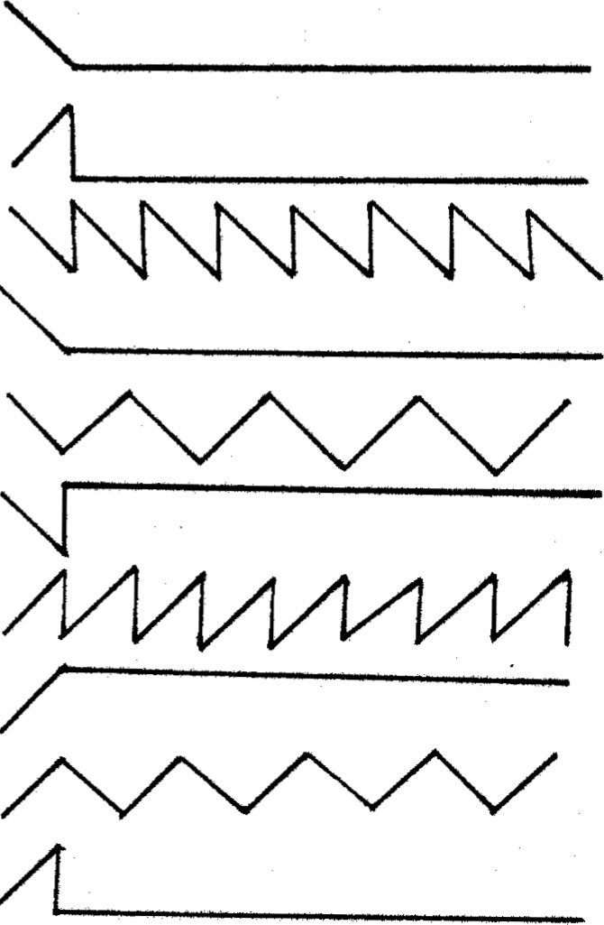
Register $0D selects the wrap curve as shown below.

Registers $0E and $0F describe the state of port A and port B.

